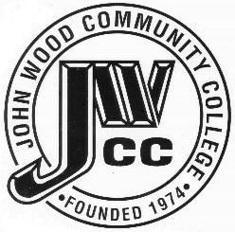 | Finance & Audit Committee Agenda  Meeting Date: 06.12.24  Meeting Time: 2:00 p.m.  Meeting Location: C240

AGENDA ITEMS:

- Review Bills for Payment

- Review Travel Requests

- Review Financials

- Review Board Budget

- Review & Discuss Investments

- Board Items

  - Tentative Budget
  - Treasurer’s Bond
  - Student Account Write-Offs

- Other

