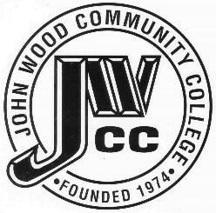 | Finance & Audit Committee Agenda  Meeting Date: 11.19 23  Meeting Time: 4:00 p.m.  Meeting Location: C240

AGENDA ITEMS:

- Review Bills for Payment

- Review Travel Requests

- Review Financials

- Review Board Budget

- Review & Discuss Investments

- Board Items

  - Tax Levy
  - Audit
  - PACT Lease
  - Two Rivers Lease

- Other
  - Financial Projections

