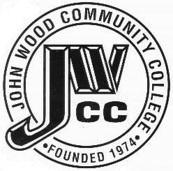 | Finance & Audit Committee Agenda  Meeting Date: 03.12 25  Meeting Time: 3:30 p.m.  Meeting Location: C240

AGENDA ITEMS:

- Review Bills for Payment

- Review Travel Requests

- Review Financials

- Review Board Budget

- Review & Discuss Investments

- Other

